

INTRO TO WEB DESIGN

Bassirou DIENG



June 15, 2022

WALSALL COLLEGE

Table of Contents

Introduction 2

Task-1 2

A comparison of HTML 4 and HTML 5, that explains the expanded capabilities of HTML 5 (LO 1.3) 2

HTML 4 2

HTML5 3

A comparison of HTML 4 and HTML 5, that explains the expanded capabilities of HTML 5 (LO 1.3) 3

Difference between HTML 4 and HTML 5 3

What is new in HTML 5? 4

Resources that will be required to create the website 5

Text editor 5

HTML and CSS 5

Website Scripting 5

Domaine and hosting 5

Web browsers 6

FTP 6

Audience and their needs 6

The file formats that are available for images and explain which of these should be used on websites and why they should be used 6

Images files formats 7

Victor files 7

Raster files 7

Choosing the right file format 8

Task-2 11

Storyboard 11

Sitemap 16

Website Development 16

References 17

# Introduction

*As I have recently been employed as a junior web developer, my employer would like to ascertain my level of understanding and skills. Therefore, they have asked me to produce a five page website on a topic of my choice. (brief)*

I will also do a comparison between HTML 4 and HTML 5 and explain their capabilities. I will also dive deep into different files formats available for images to use within a website and their applications and limitations.

Once coming to the design and development I will be preparing a sitemap and storyboard for my website then I will follow the structure to build my website.

# Task-1

# A comparison of HTML 4 and HTML 5, that explains the expanded capabilities of HTML 5 (LO 1.3)

## HTML 4

Commonly known as HTML, Hyper Text Markup Language is a markup language that's used to build websites. HTML is a markup language that combines hypertext with markup. When saying the term "hypertext" it is referring to the link between web pages.

This language would be used to annotate (at the note for computer) text so that it may be understood by a machine and manipulated appropriately. The majority of markup languages are human readable HTML is one of them. Tags are used in the language to specify what type of text processing is required. It is used for organising and presenting content on web pages.

Web browsers are told how to render material using HTML code. It describes a web page's basic structure. HTML, together with Cascading Style Sheets (CSS) and JavaScript, has long been regarded as a fundamental innovation of the World Wide Web. The standards of HTML and CSS are charged and maintained by The W3C.

As its name defines, HTML is a markup language which is used to structure data from the internet, therefore, it is not technically a programming language. To categorise material, HTML documents are made up of HTML elements symbolized by tags, which also are typed inside angle brackets. The following is an example of an HTML structure for displaying a simple "Hello World" message:

HTML pages supplied from web servers instruct the browser on how to display text, as well as links, images, and interactive forms.

## HTML5

Since its inception in the late 1980s, HTML, like everything in the tech world, has evolved tremendously.

HTML5 is the most recent version of the HyperText Markup Language, and it now includes multimedia, tags, and elements, as well as better document markups and new APIs.

HTML5 was created to do practically everything you would want to be doing online without the use of third-party software like browser plugins. It can accomplish everything including animation to apps, music to movies, and it can even be used to create extremely complex web applications.

Because HTML5 is really not proprietary, you won't have to pay any royalties if you utilise it. It is also cross-platform, meaning means it should operate seamlessly on any device that supports HTML5, including tablets, smartphones, netbooks, notebooks, Ultrabooks, and Smart TVs. It is almost always a little more complex than that.

We have gone a long way from the days when HTML could not even manage a basic website layout. HTML5 can be used to create online apps that work even if you are not connected to the internet, to inform websites in which you are physically located, to handle high-definition video, and to deliver amazing graphics.

# A comparison of HTML 4 and HTML 5, that explains the expanded capabilities of HTML 5 (LO 1.3)

## Difference between HTML 4 and HTML 5

HTML and HTML5 are hypertext markup languages (HTML and HTML5) that are primarily used to develop web pages or apps. HTML5 is the most current version of HTML, and it includes new markup language features including multimedia, additional tags and elements, and APIs. Video and audio are also enabled by HTML5.

The primary difference between the two is that HTML4 has fewer elements, tags, and attributes than HTML5.In other words, HTML5 is a new and advanced edition that addresses all of the problems.

The primary distinction between HTML4 and HTML5 is that some elements and properties are no longer used in HTML5. This is not to say that the only distinction between HTML5 and HTML4 is the elements and attributes that developers utilise.

When the last significant version, HTML4.01, was implemented in 1999, the Internet was a totally different world. We now have technologies that we could not have envisioned well before the turn of the century. Engineers and software programmers face additional constraints as a result of smartphones, tablets, and other mobile devices. The standardisation of Internet technology has become a primary issue for everyone involved in the global economy as a result of increased globalisation. Year after year, global Internet usage increases, and the technology used is expected to advance at an ever-faster pace.

## What is new in HTML 5?

Why was HTML upgraded in 2014 if it had been fine for over a decade? The incorporation of multimedia content into the language's specs is the most major distinction between prior versions of HTML and HTML5. HTML5 also contains the following improvements:

* The use of deprecated elements such as centre, font, and the strike has been discontinued.
* Parsing rules have been improved, allowing for more flexibility and compatibility.
* Video, time, navigation, segment, progress, metre, aside, and canvas are all new elements.
* Email, URL, dates, and times are among the new input attributes.
* charset, async, and ping are among the new characteristics.
* Offline caching, drag-and-drop functionality and other features are now available using new APIs.
* Without the need for Silverlight or Flash, vector graphics can be displayed.
* MathML support is included to improve the display of mathematical notations.
* JavaScript can now run in the background thanks to the JS Web worker API.

Furthermore, the image below illustrates a quick overview of HTML5's main characteristics per classification.

# Resources that will be required to create the website

For a website to be created there are some resources required which we will be discussing. These include but not limited to the following:

### Text editor

For a website to be created, it is necessary to have a text editor where all your HTML and CSS will be written in.

There are dozens of text editors available to choose from free to premium. However, you can search the one suits you and go for it. Notepad++, Atom, Sublime Text, Visual Studio are examples of text editors.

### HTML and CSS

The foundational languages of websites are HTML and CSS, and both are required to create an effective website. HTML without CSS would not only look bad, but it may also give the impression that there is a significant issue with your website.

Compared to other programming languages, HTML and CSS are fairly simple to master.

### Website Scripting

HTML and CSS are essential to any website. However, website scripting could also be necessary, depending on what type of website you're constructing. A static website is transformed into a dynamic website using website scripting. Scripting will probably be required for, or at least advantageous for, your website. Website scripting examples include the following:

* contact forms
* interactive buttons and controls
* website databases
* shared content between web pages

### Domaine and hosting

Web hosting is a service that stores the HTML, CSS, photos, scripts, and other website files on a server for public access. Your website's address is its domain name (for instance, bassirou.com).

Online retailers of domains and hosting services come in a variety of forms. You should look at some of the well-known choices, such as Dreamhost, GoDaddy, Media Temple, NameCheap, HostGator, and Bluehost.

There are three types of hosting:

* ***Shared hosting:***

The least expensive option a web host will offer is shared hosting. On the same server as your website, there will likely be 200 or more other websites. In terms of accommodation, it is similar to "flatting," where you receive a room but share the home and the amenities with the other housemates.

* ***VPS hosting:***

VPS hosting is still shared, but relying on how much you are prepared to spend to upgrade your plan, you have more space to run your website. It's like to having an entire apartment to oneself. Compared to shared hosting, this costs more.

* ***Dedicated hosting:***

With dedicated hosting, your website will be housed on a separate server. Typically, very large companies choose this option. You are in total command. There is no need to share so it's like having the entire building to oneself. You should budget several hundred bucks a month.

### Web browsers

You must also ensure that your website displays and operates properly in each web browser because each one produces HTML and CSS differently.

As you are already aware, a web browser is required to view websites. Although there are numerous browsers available for personal use, you should test a website you're building at least with the following popular browsers to ensure it functions for the majority of users: Google Chrome, Microsoft Internet Explorer, Mozilla Firefox, Apple Safari etc.

### FTP

Use file transfer protocol, or FTP, to move your website's files from your computer to the server that will host your website. Simply put, this refers to posting files to the Internet.

A service that allows you to upload files throughout a web interface is often available when you log into your hosting account. As an alternative, you can upload your files using a tool like FileZilla without going to your hosting account.

## Audience and their needs

I intend to produce a website which is proof of concept that can focus on any particular genre of music of my choice, therefore I will be producing a website that focuses on a classic singer and rapper Akon. My target audience will be the world of music, those who love R&B and hip-hop specially Akon’s audience. Based on my research, my audience needs this website to include events, labels, news, gallery and many more things concerning the American-Senegalese artist Akon. The website needed to be easy to navigate and fast to load, it needs to have a consistent house style across all the web pages, with a professional looking and appeals to whoever will surf to this website.

# The file formats that are available for images and explain which of these should be used on websites and why they should be used

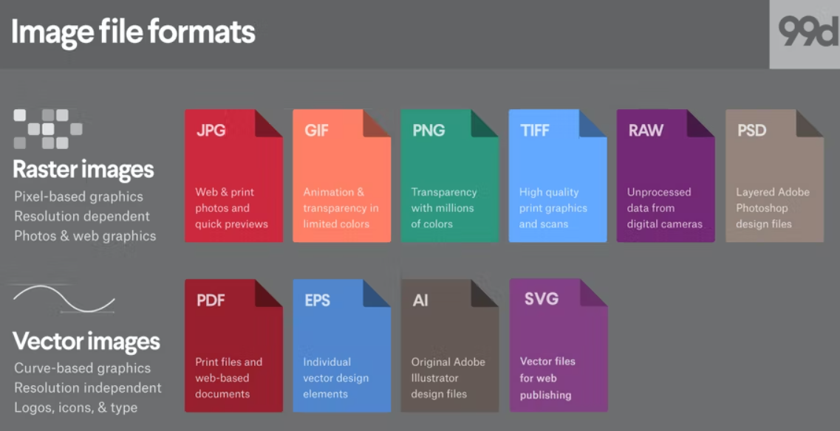Every image you view online is a file called an image. The majority of what you see printed on items like paper, plastic, or t-shirts originated as an image file. These files are available in several forms, and each one is tailored for a certain purpose. Your design will be exactly as you wanted it to be if you use the proper type for the job. A terrible print, a subpar web image, a large download, or a missing graphic in an email could all result from using the incorrect format.

## Images files formats

JPEGs, GIFs, PNGs, and more image types are available as web images. In fact, there are so many abbreviations that remembering them can be challenging, let alone choosing the ideal picture format for your website.

Raster files and vector files are the two broad categories into which the majority of image files fall, and each category has a variety of applications. This analysis is not flawless. For instance, some formats can really have components from both types. But when deciding which format to employ for your work, this is an excellent place to start.

### Victor files

In vector graphics, an image is represented by lines, points, and polygons. They perform well for logos and icons and are better suited for simple geometric designs.

Because they can be scaled indefinitely without losing quality, vectors are perfect for high-resolution screens of all shapes and sizes. Vectors, however, are not the ideal file format for saving photographs.

SVG, PDF, EPS and AI are types of vector files formats.

### Raster files

Raster graphics represent an image by using pixel values within a rectangular grid. For complex pictures like photographs, they work best.

These file types can't be expanded without losing any quality and becoming distorted since, unlike vectors, they depend on resolution and size. Online photos typically come in raster format.

JPEG, PNG, GIF, TIFF, PSD are types of raster formats.

Since the image formats you employ on your site have an effect, it's necessary to give this some thought. For instance, some forms of graphics appear better and take up less storage space, which translates to greater performance without a drop in quality.

### Choosing the right file format

There are many different image formats available, as we have already explained. However, when it comes to the website, the majority of people stick to a few tried-and-true formats, such JPEGs, PNGs, and GIFs.

In a moment, we'll discuss what distinguishes each of these image types. Let's explain why, in general, the format(s) you employ on your website matter now.

The following are some features that could be affected by the types of images you used:

* **Performance** - the size of a picture can determine how quickly a website loads. Some image file formats require a larger than others.
* **Appearance** - As you may expect, certain image formats have better quality and more information than others.
* **Scalability** - Over-stretching or under-stretching an image will degrade its quality. The image format you pick will determine how much room you have. This has an impact on how well-designed your site is for both large and small displays.

For your website to maintain a consistent standard, you should often stick to employing just one or two image formats. In an ideal world, the formats you select should strike a good balance between performance and quality.

As we discussed earlier, there are dozens of images types available to choose from however, I will be narrowing this and only outline the three primary files formats used in website. This will be a comparison between: JPEG, PNG and GIF.

***JPEG (or JPG):***

A raster-based image designed for the web and print is stored as a JPG file. The JPG format is the default file format for digital photography and is the most widely used picture format on the web due to its universal compatibility and compression.

The optimal usage for these files is to store photos with modest file sizes and barely perceptible quality loss. Since JPGs employ lossy compression, the quality degrades with each subsequent saving.

For the intended use, JPGs must be saved in the appropriate size and resolution. Social networking sites utilise predetermined image sizes to regulate resolution, prevent pixelation and image stretching, and guarantee that the entire picture will be visible.

***Advantages:***

* support for all browsers
* Quick loading, small file and email attachment sizes
* supports the display of countless colours
* clear, high-quality photographs

***Disadvantages:***

* Does not support backgrounds with transparency
* Lossy picture compression results in low-quality or difficult-to-read typography.
* For non-computer-generated visuals only

***PNG:***

A PNG format is typical for use on the web. Since these files are pixel-based, scaling them up causes pixelation. This means that, like JPGs, they must always be exported with the appropriate size for the intended use.

For graphics (not photographs), a PNG file allows translucent backgrounds and maintains overall superior image quality than JPGs because to lossless compression—you could save a PNG without losing any quality.

PNGs are significantly more suited for visuals with fewer colours and crisp transitions between colours, such as logos, icons, and straightforward illustrations.

On digital and mobile devices, PNGs produce a clearer, more defined image, so utilise them on your website and social media. Make your PNG files as little as possible while preserving high quality to optimise them for the web.

***Advantages:***

* support for all browsers
* in favour of transparency
* ideally suited for use with graphics
* compressed without loss
* little file size and few colour options

***Disadvantages:***

large file size and countless colour variations

Not the best for printing; screen-optimized

***GIF:***

Graphics Interchange Format, or GIF, is a lossless raster format. How is it pronounced, that is the key question? GIF's creator pronounces "JIFF" like peanut butter. The reason this writer (and many others) say "GIFF" is that graphics begin with a "guh." Anyway, we'll let you decide that. Another popular web image format is GIF, which is frequently used for animated visuals like banner ads, email images, and social media memes. Despite the fact that GIFs are lossless, it is possible to export them using a variety of highly adjustable options that minimise the number of colours and visual details, hence shrinking the file size.

The majority of image editors and all popular web browsers support GIF for the only animated image format. Transparency and animation are supported through GIFs, which can also be extensively compressed to save file size.

***Advantages:***

* Useful for brief animation and low-resolution video clips is animation support.
* support for all browsers
* little-sized files

***Disadvantages:***

* loss of photographic quality
* 8-bit's limitations on colour (PNG and JPG supports 24-bit)
* concerns with copyright

# Task-2

## Storyboard

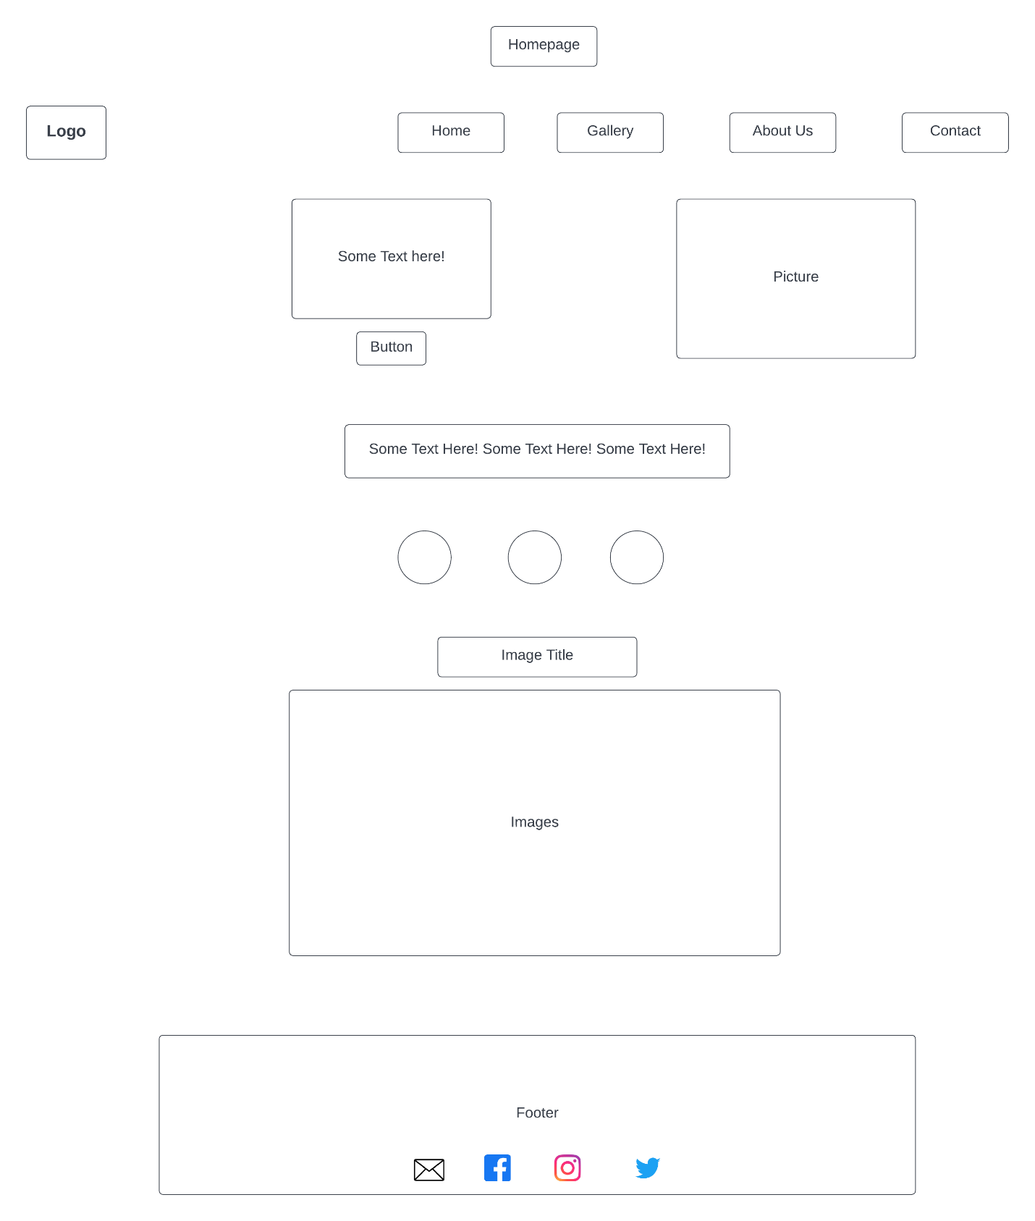

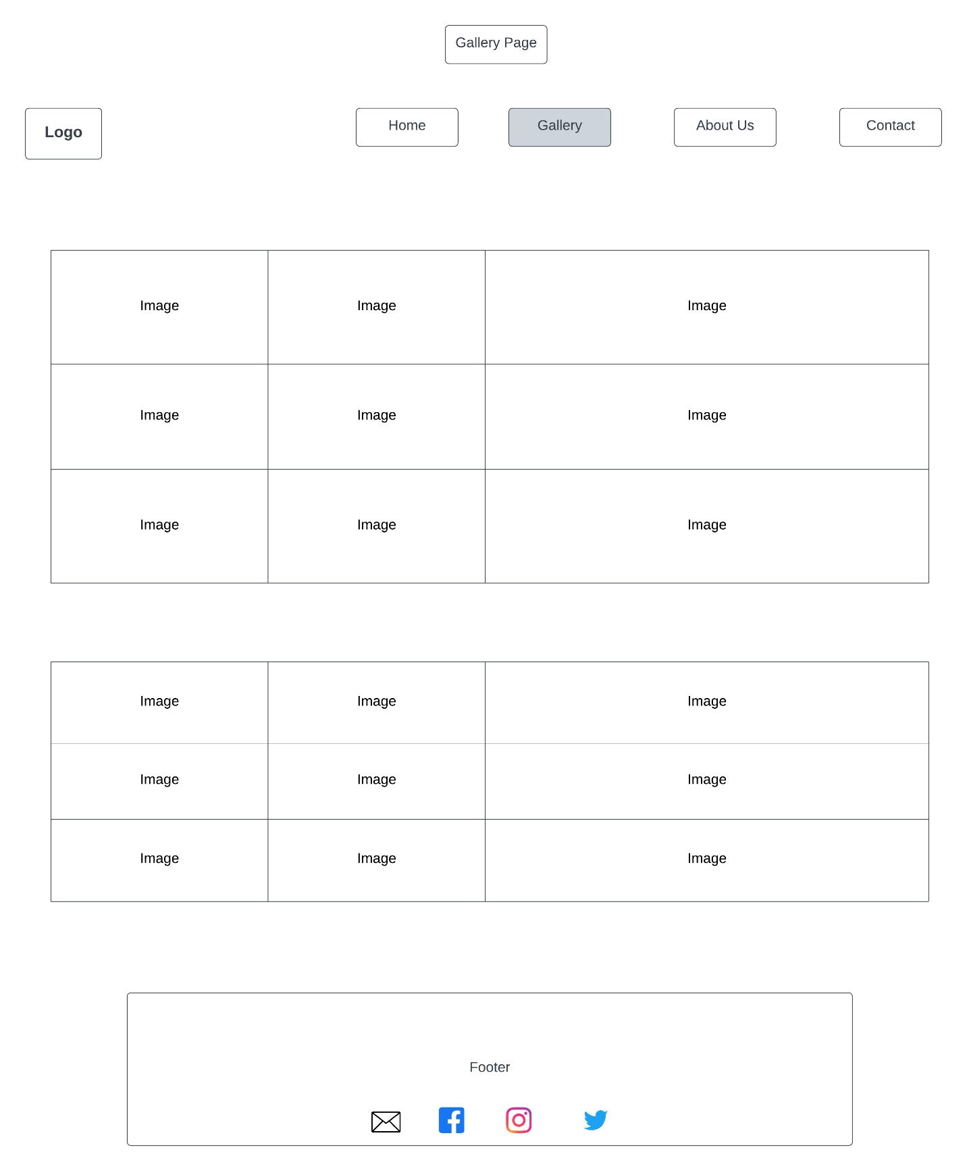

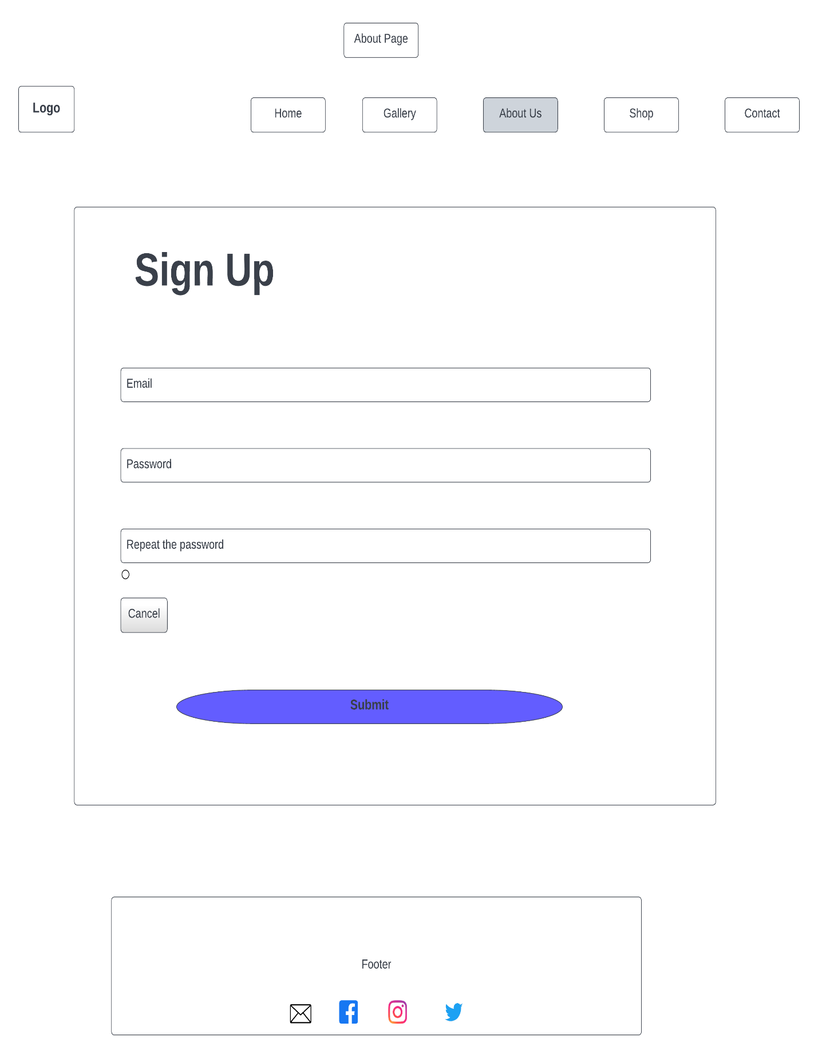

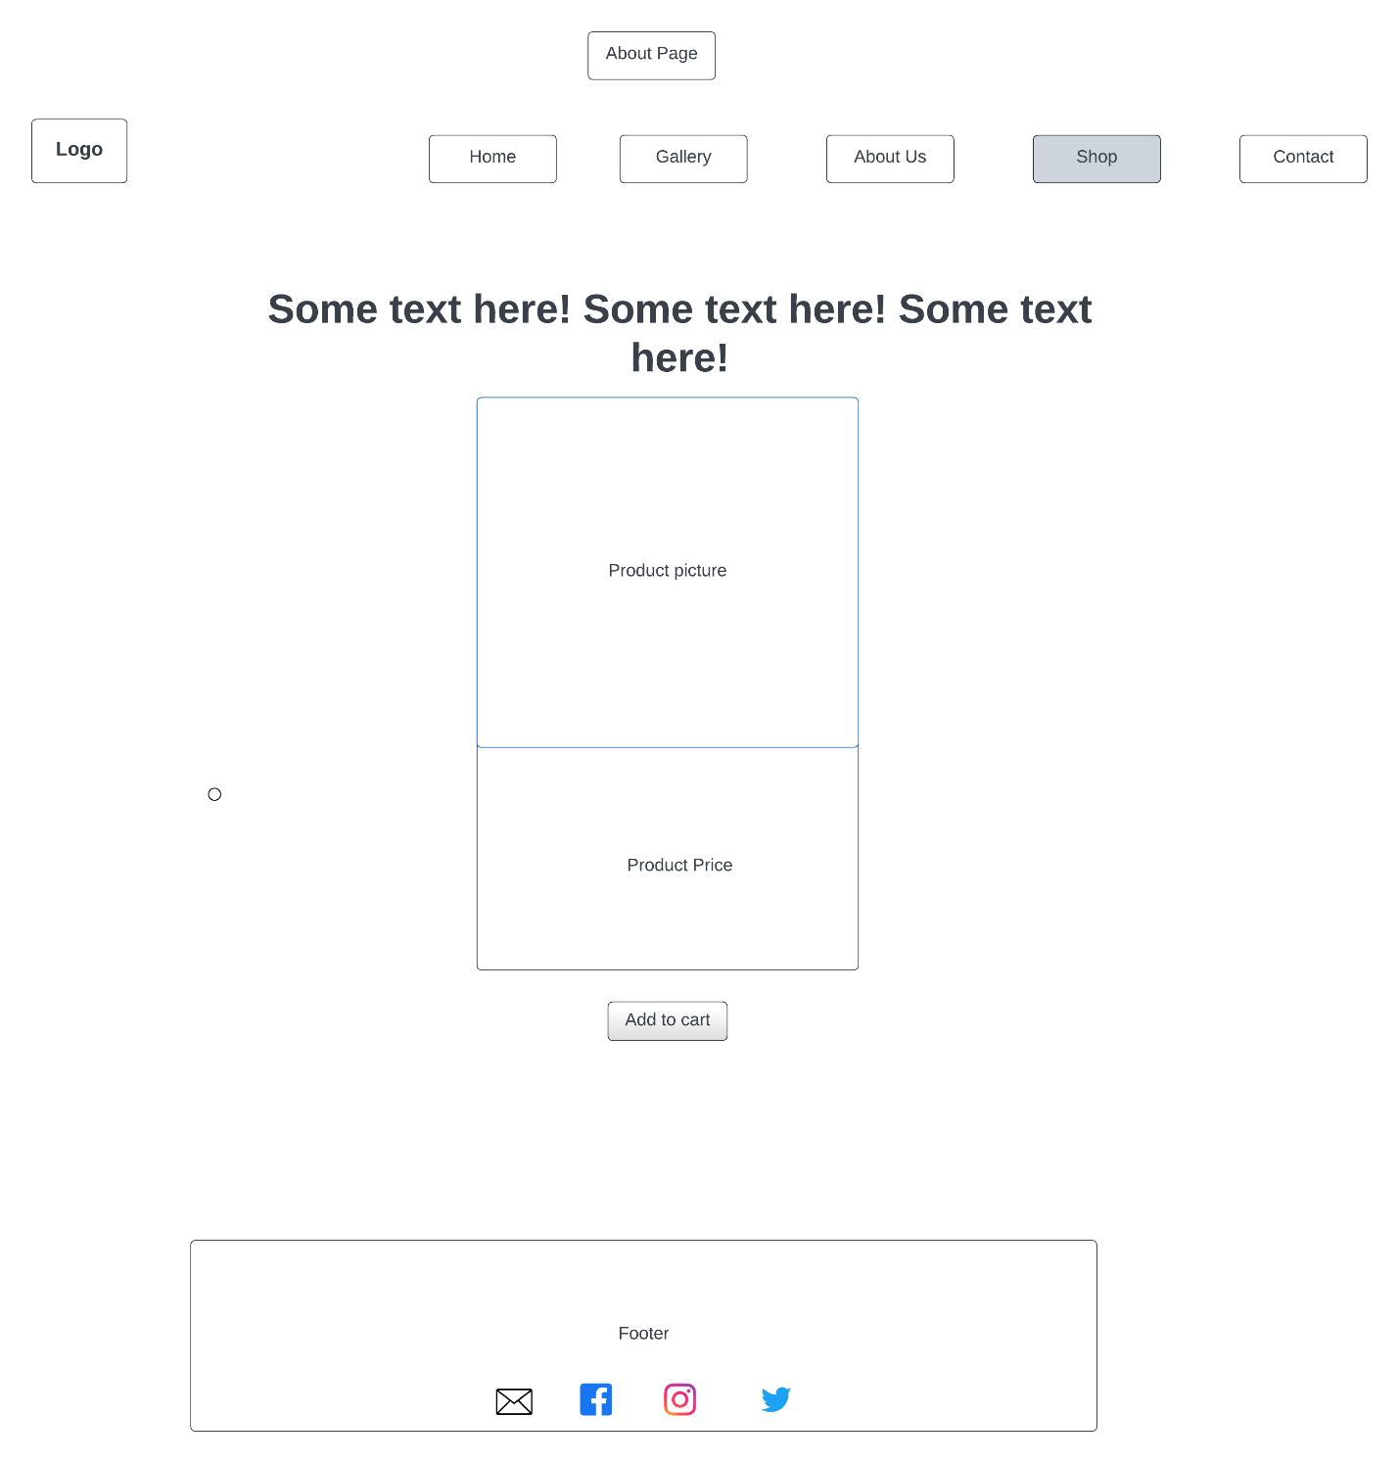

Shop Page

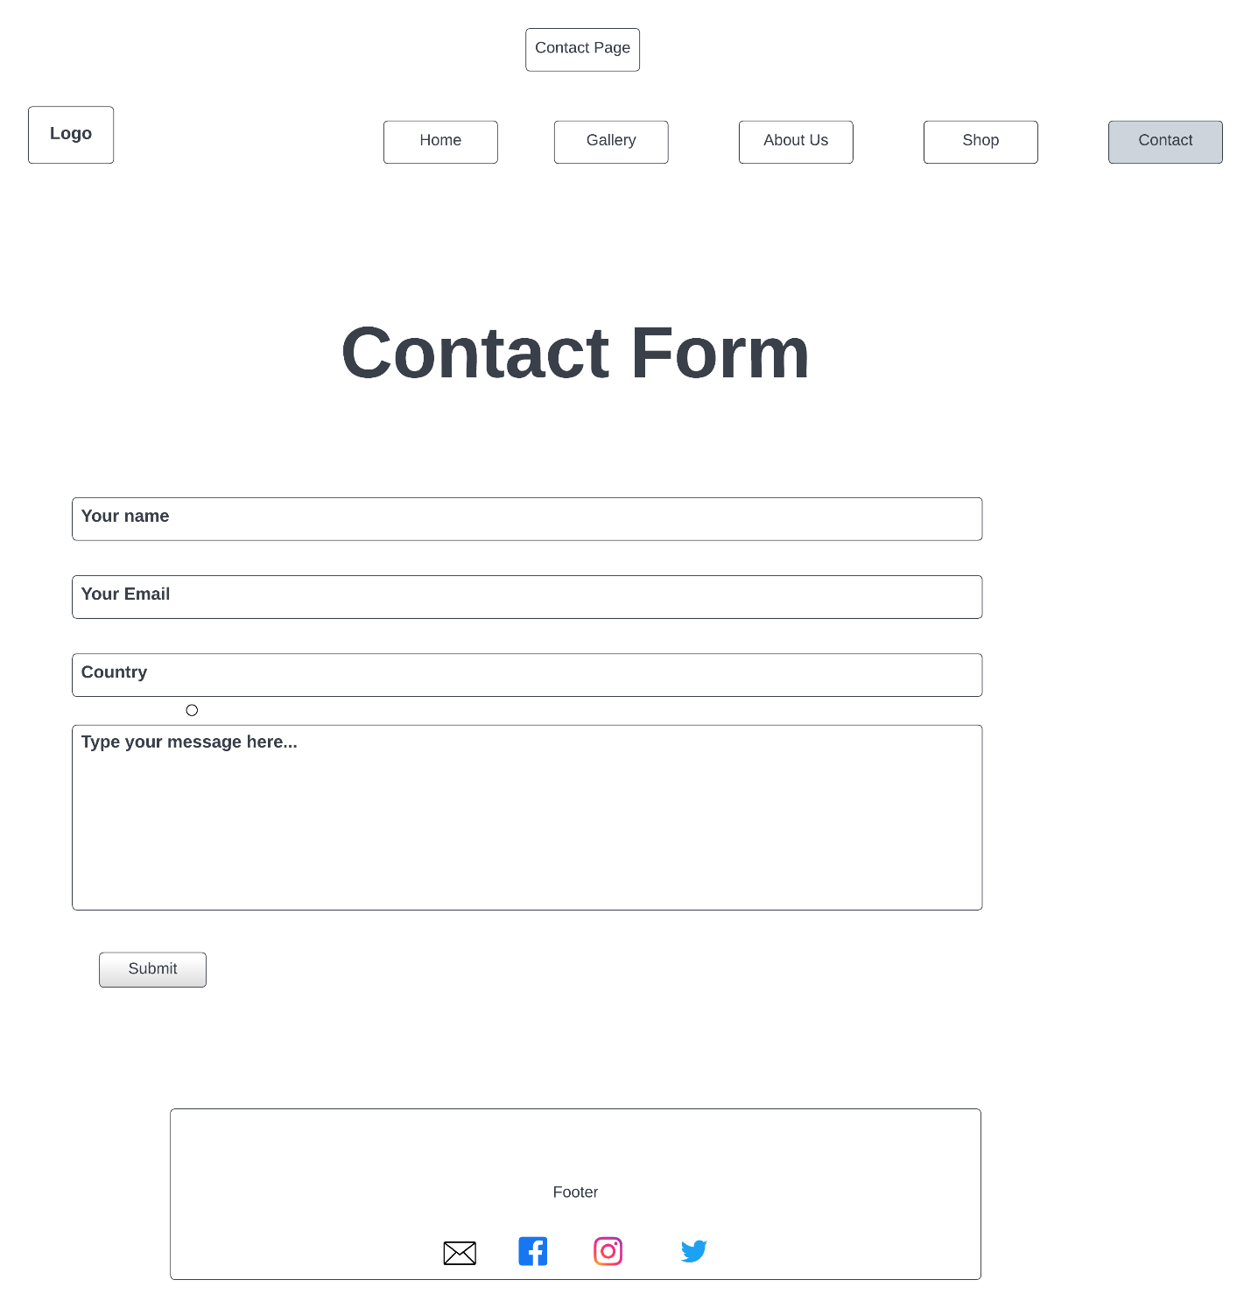



## Sitemap

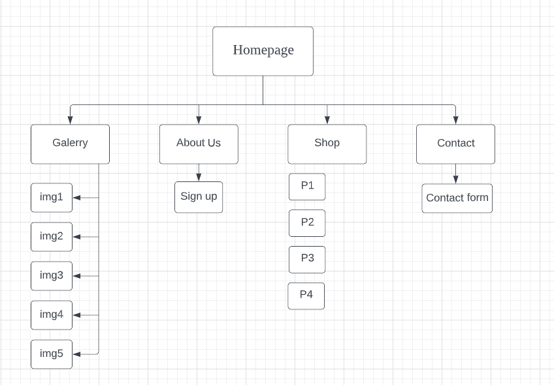

## Website Development

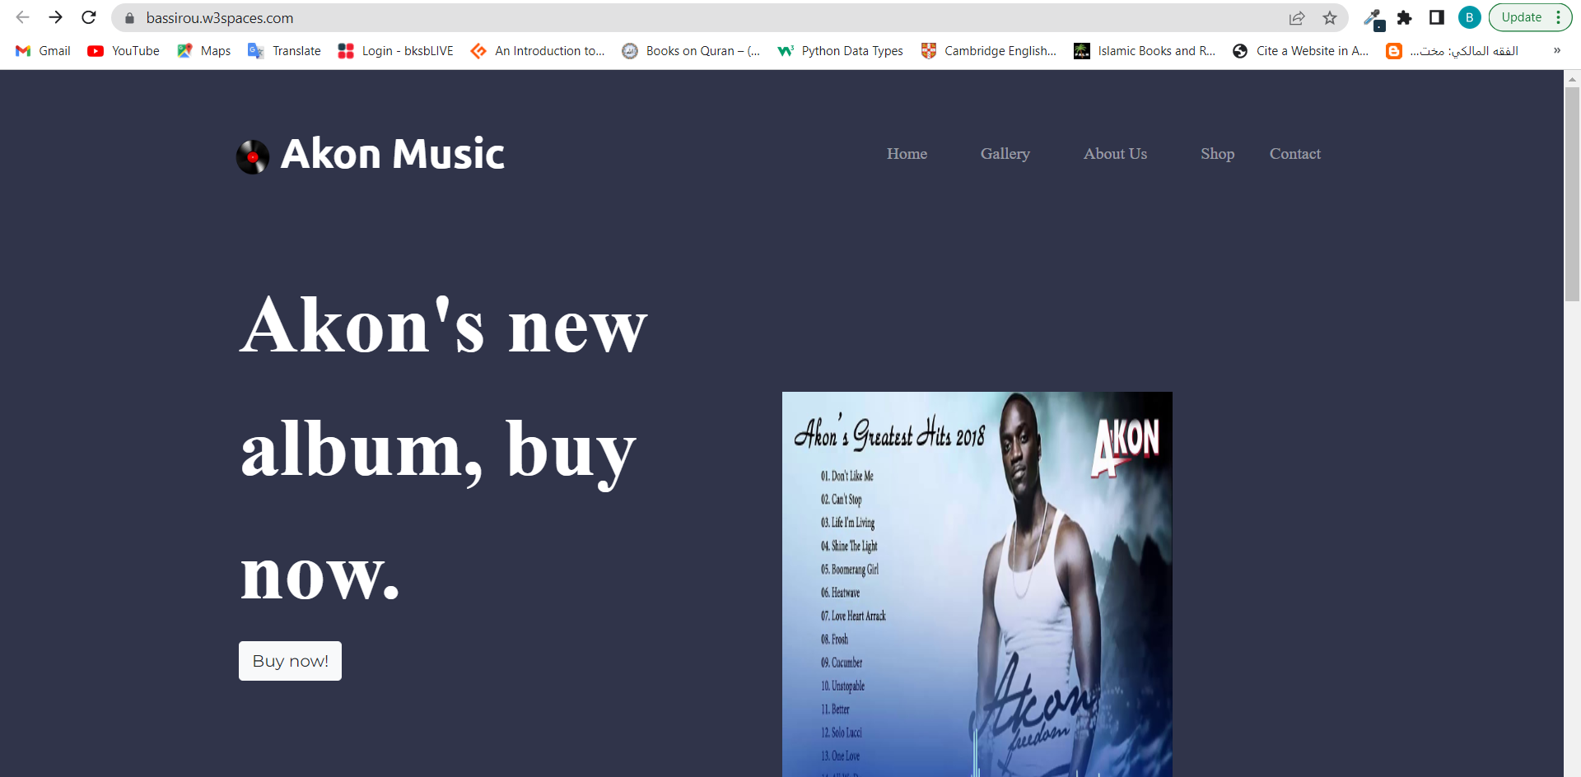I have fully developed my website and uploaded it using W3Schools. You can access my website by clicking this link: <https://bassirou.w3spaces.com/>.

# References

www.geeksforgeeks.org. 2022. *https://www.geeksforgeeks.org/difference-between-html-and-html5/*. [online] Available at: <https://www.geeksforgeeks.org/difference-between-html-and-html5/> [Accessed 10 June 2022].

www.hostinger.co.uk. 2022. *What Is the Difference Between HTML and HTML5*. [online] Available at: <https://www.hostinger.co.uk/tutorials/difference-between-html-and-html5#HTML_vs_HTML5_-_Comparison> [Accessed 16 June 2022].

Arsenault, C., 2017. *HTML vs HTML5 - What Is the Difference?*. [online] www.keycdn.com. Available at: <https://www.keycdn.com/blog/html-vs-html5> [Accessed 18 June 2022].

Marshall, C., 2017. *HTML5: what is it?*. [online] www.techradar.com. Available at: <https://www.techradar.com/uk/news/internet/web/html5-what-is-it-1047393> [Accessed 14 June 2022].

KRAUSE, E., 2022. *How to Choose the Best Image File Format for Your Website*. [online] www.designpowers.com. Available at: <https://www.designpowers.com/blog/image-file-formats> [Accessed 30 June 2022].

HUGHES, J., 2022. *What’s the Best Image Format for Your Website?*. [online] themeisle.com. Available at: <https://themeisle.com/blog/best-image-format/> [Accessed 1 July 2022].

www.codeconquest.com. 2022. *What is Needed for a Website?* [online] Available at: <https://www.codeconquest.com/website/what-is-needed-for-a-website/> [Accessed 1 July 2022].